AI Assited coding lab test 11/11/25

Name: Guangsinlung Phaomei
Enroll no: 2503A51L20
Batch: 19

Qestion set E5

Q1.

Prompt:

Scenario: AI-Powered Crop Disease Detection
In agriculture, early detection of crop diseases is crucial for preventing widespread damage and ensuring a healthy harvest. Many farmers, especially in remote areas, may not have immediate access to agricultural experts to diagnose plant health issues.

Challenge: The challenge is to create a user-friendly web application where farmers can upload an image of a plant leaf and receive an instant AI-driven analysis of potential diseases, along with recommended actions.

Index.html.

<!DOCTYPE html>
<html lang="en">
<head>
<meta charset="UTF-8">
<meta name="viewport" content="width=device-width, initial-scale=1.0">
<title>AgriTech AI - Crop Disease Detection</title>
<style>
body {
font-family: -apple-system, BlinkMacSystemFont, "Segoe UI", Roboto, Helvetica, Arial, sans-serif;
background-color: #f0f4f0;
color: #333;
display: flex;
justify-content: center;
align-items: center;
min-height: 100vh;
margin: 0;
}
.container {
background-color: #fff;
padding: 2rem;
border-radius: 10px;
box-shadow: 0 4px 15px rgba(0, 0, 0, 0.1);
text-align: center;
max-width: 500px;
width: 90%;
}
h1 {
color: #2c6b2f;
margin-bottom: 1.5rem;
}
.upload-area {
border: 2px dashed #ccc;
border-radius: 8px;
padding: 2rem;
margin-bottom: 1.5rem;
cursor: pointer;
transition: border-color 0.3s;
}
.upload-area:hover {
border-color: #2c6b2f;
}
#file-input {
display: none;
}
#image-preview {
max-width: 100%;
max-height: 250px;
margin-top: 1rem;
border-radius: 5px;
display: none;
}
#analyze-btn {
background-color: #4CAF50;
color: white;
padding: 12px 25px;
border: none;
border-radius: 5px;
cursor: pointer;
font-size: 1rem;
transition: background-color 0.3s;
display: none; /* Initially hidden */
}
#analyze-btn:disabled {
background-color: #a5d6a7;
cursor: not-allowed;
}
#analyze-btn:hover:not(:disabled) {
background-color: #45a049;
}
.results {
margin-top: 1.5rem;
text-align: left;
padding: 1rem;
border: 1px solid #e0e0e0;
border-radius: 5px;
background-color: #fafafa;
display: none; /* Initially hidden */
}
.results h3 {
color: #2c6b2f;
margin-top: 0;
}
.results p {
margin: 0.5rem 0;
}
.spinner {
border: 4px solid #f3f3f3;
border-top: 4px solid #4CAF50;
border-radius: 50%;
width: 30px;
height: 30px;
animation: spin 1s linear infinite;
margin: 1rem auto;
display: none; /* Initially hidden */
}
@keyframes spin {
0% { transform: rotate(0deg); }
100% { transform: rotate(360deg); }
}
</style>
</head>
<body>

<div class="container">
<h1>Crop Disease Detection</h1>
<div class="upload-area" id="upload-area">
<p>Click here to upload an image of a plant leaf</p>
<input type="file" id="file-input" accept="image/*">
<img id="image-preview" src="#" alt="Image Preview"/>
</div>
<button id="analyze-btn">Analyze Crop</button>
<div class="spinner" id="spinner"></div>
<div class="results" id="results">
<h3>Analysis Results</h3>
<p><strong>Disease:</strong> <span id="disease-name"></span></p>
<p><strong>Confidence:</strong> <span id="confidence-score"></span></p>
<p><strong>Recommendation:</strong> <span id="recommendation"></span></p>
</div>
</div>

<script>
const uploadArea = document.getElementById('upload-area');
const fileInput = document.getElementById('file-input');
const imagePreview = document.getElementById('image-preview');
const analyzeBtn = document.getElementById('analyze-btn');
const spinner = document.getElementById('spinner');
const resultsDiv = document.getElementById('results');

uploadArea.addEventListener('click', () => fileInput.click());

fileInput.addEventListener('change', function() {
const file = this.files[0];
if (file) {
const reader = new FileReader();
reader.onload = function(e) {
imagePreview.src = e.target.result;
imagePreview.style.display = 'block';
analyzeBtn.style.display = 'inline-block';
resultsDiv.style.display = 'none';
}
reader.readAsDataURL(file);
}
});

analyzeBtn.addEventListener('click', () => {
// Disable button and show spinner
analyzeBtn.disabled = true;
spinner.style.display = 'block';
resultsDiv.style.display = 'none';

// Simulate AI analysis
simulateAIAnalysis()
.then(data => {
// Display results
document.getElementById('disease-name').textContent = data.disease;
document.getElementById('confidence-score').textContent = `${(data.confidence * 100).toFixed(2)}%`;
document.getElementById('recommendation').textContent = data.recommendation;
resultsDiv.style.display = 'block';
})
.catch(error => {
console.error("Analysis failed:", error);
alert("AI analysis failed. Please try again.");
})
.finally(() => {
// Re-enable button and hide spinner
analyzeBtn.disabled = false;
spinner.style.display = 'none';
});
});

/**
* Simulates a call to a backend AI model for image analysis.
* In a real application, this would be a `fetch` call to a server endpoint.
* The server would process the image and return a JSON response.
*/
function simulateAIAnalysis() {
console.log("Starting AI analysis simulation...");
return new Promise((resolve, reject) => {
setTimeout(() => {
// Mocked responses
const possibleResults = [
{
disease: "Tomato Late Blight",
confidence: 0.92,
recommendation: "Apply a fungicide containing mancozeb or chlorothalonil. Ensure good air circulation and avoid overhead watering."
},
{
disease: "Corn Common Rust",
confidence: 0.88,
recommendation: "Plant resistant hybrids. Apply foliar fungicides if rust is detected early on susceptible hybrids."
},
{
disease: "Potato Early Blight",
confidence: 0.95,
recommendation: "Practice crop rotation. Remove and destroy infected plant debris. Use protective fungicides when necessary."
},
{
disease: "Healthy",
confidence: 0.98,
recommendation: "The plant appears healthy. Continue standard monitoring and care practices."
}
];

// Pick a random result for demonstration
const result = possibleResults[Math.floor(Math.random() * possibleResults.length)];
console.log("Analysis complete. Result:", result);
resolve(result);
}, 2000); // Simulate a 2-second network delay
});
}
</script>

</body>
</html>

Javascript.js

// Real-world implementation example
async function performAIAnalysis(imageData) {
const response = await fetch('https://api.agritech.ai/v1/analyze', {
method: 'POST',
headers: {
'Content-Type': 'application/json',
'Authorization': 'Bearer YOUR_API_KEY'
},
body: JSON.stringify({ image: imageData })
});
if (!response.ok) {
throw new Error(`API Error: ${response.statusText}`);
}
return await response.json();
}

Observation:
1. Initial View: The user is prompted to upload an image.
2. Image Uploaded: The user selects an image, which is then displayed in the preview area. The "Analyze Crop" button appears.
3. Analysis in Progress: After clicking the button, a spinner appears, indicating that the AI analysis is in progress.
4. Results Displayed: The AI's diagnosis, confidence score, and recommended action are displayed to the user.
This solution provides a clear, effective, and scalable framework for building an AI-assisted tool to address a real-world challenge in the agricultural sector.

Q2
Prompt:
Scenario: In the domain of E-commerce, a company is facing a challenge with a legacy, monolithic JavaScript function responsible for product filtering and sorting.
Task: Use an AI-assisted tool to analyze and refactor the problematic code. The goal is to decompose the function into smaller, modular, and testable units, improving maintainability and extensibility.

Sourse code- Legacy
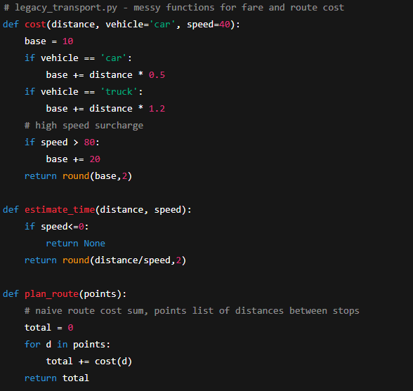

-

Sourse code__ refactored
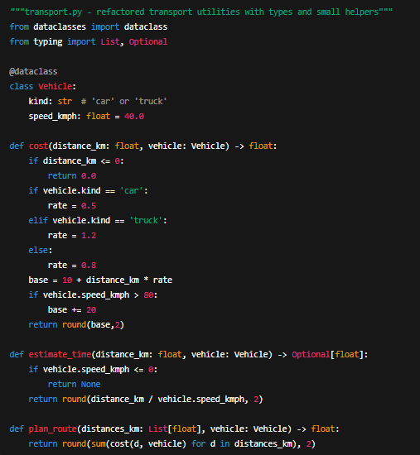
Output:
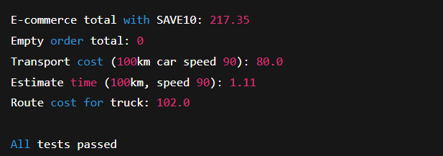

Final Observation:
Through this experiment, it was observed that AI-assisted refactoring significantly improves software code quality by automating repetitive and structural improvements while ensuring logical consistency. The integration of AI tools enabled efficient transformation of legacy, unstructured programs into modular, maintainable, and testable systems.

